

SHANGHAI MARITIME UNIVERSITY

Smart Seat

**Group 8**

|  |  |
| --- | --- |
| **Course：** | Software project management |
| **Group members：** | Hanyu Zhang, Tinghui Zhang, Huiying Han, Yikang Tao |
| **Teacher：** | Jin Liu |
| **Date:** | 2019-5 |

**Directory**

|  |  |
| --- | --- |
| **Part I** | Project Plan |
| **Part II** | Gannt Chart |
| **Part III** | Statement Of Work |
| **Part IV** | Details Design |
| **Part V** | Test Plan |
| **Part VI** | Risk Plan |
| **Part VII** | The First Presentation |
| **Part VIII** | The Second Presentation |
| **Part IX** | Test Cases |
| **Part X** | Lessons Learnt |
| **Part XI** | Future plan for next cycle |

Smart Seat

Project Plan V0.9

**Group members：**Hanyu Zhang, Tinghui Zhang, Huiying Han, Yikang Tao

**Directory**

Smart Seat 3

1 Introduction 6

1.1 The purpose of writing 6

1.2 Background 6

1.3 Define 6

1.4 Reference 7

1.5 Standards、conditions and conventions 7

2. Description of project 8

2.1 Project target 8

2.2 Project objectives and scope 8

2.3 Assumptions and constraints 8

2.4 Scope of project work 9

2.5 Deliverables 9

2.5.1 Products to be completed 9

2.5.2 The user’s documentation needs to be submitted 9

2.5.3 Internal documents need to be submitted 9

2.5.4 Services to be provided 10

2.6 Project development environment 10

2.7 Method and basis of project acceptance 10

2.7.1 Acceptance of code 10

2.7.2 Acceptance of documents 10

2.7.3 Acceptance of services 11

3 Project team organization 12

3.1 The structure of the organization 12

3.2 Personnel division of labor 12

3.3 Collaboration and communication 13

4 Carry out the plan 14

4.1 Risk assessment and countermeasures 14

4.2 Overall schedule 14

5 The budget 15

5.1 The cost of equipment 15

5.2 Personnel costs 15

5.3 Other budget 15

# 1 Introduction

## 1.1 The purpose of writing

If you want to successfully complete the development of a software project, you must first have a unified plan, in which all the project participants need to clarify their responsibilities, ensure the orderly collaboration between the project team, so that all the processes in the project can be carried out in a reasonable and orderly way. At the same time, the plan can also play a guiding role in the communication within and outside the team, the scope of work between the teams, the relationship between development modules, and the development schedule, budget, allocation of human and material resources, risks and other factors are described roughly.

This project plan is mainly used to guide the smooth progress of the "smart seat" project and ultimately design the approved project products. The project plan is open to all members of the project team.

## 1.2 Background

At present, there are many seats in university libraries, but there are still a large number of seats in short supply in the peak period of use, and occasionally some students are unhappy because of the seat occupying behavior. Many students in the library after a long time search, still did not find a place to learn to read, delayed a lot of time, which greatly reduced the students' enthusiasm for learning.

The current library equipment is perfect, but the repair is not timely, although there is often a location, but because of the damage of the hardware facilities as a result of the normal use of the situation.

## 1.3 Define

Technical terms:

**MySQL:** database relational system (DBMS) used by the system server.

**SQL:** a language for accessing query databases

**Transaction flow:** data may be processed in multiple paths once it enters the module.

**SQL:** Structured Query Language.

**UML:** unified modeling language (UML) is a set of standard modeling language to design software blueprints. It is a standardized modeling language from software analysis, design to programming specifications.

## 1.4 Reference

《Software project management》Rajeev T Shandilya Science press

《UML and pattern applications》Craig Larman Machinery industry press

National standards document for software engineering

## 1.5 Standards、conditions and conventions

The project follows the following standards:

**GB/T** computer software classification and code

**GB/T** information technology

**GB/T** software engineering

**GB/T** software engineering standard taxonomy

**GB/T** computer test documentation

**GB/T** computer software requirements specification

**GB/T** computer software testing specifications

**GB/T** information technology programming language

**GB/T** information technology software engineering

**GB/T** computer software documentation specifications

## 1.6 WBS

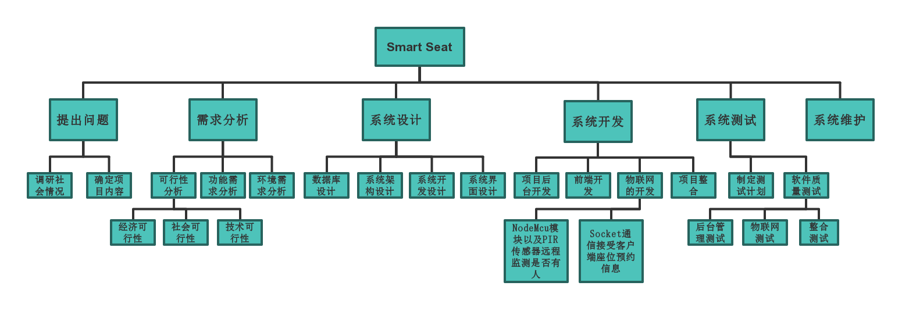

# 2. Description of project

## 2.1 Project target

* Design a smart seat occupying system sample based on the Internet of things
* Developed can be put into use of the intelligent seat background management system

## 2.2 Project objectives and scope

Smart Seat will eventually realize intelligent Seat system through the web system view the current state of the library's Seat (free, taking up, busy), if the Seat is in the idle state library, can Seat reservation, if Seat after a period of time after the scheduled nobody manually to Seat the system will automatically release the Seat to idle state; If the seat is in the scheduled valid time, the sensor senses that there is someone at the seat, but no one manually confirms the arrival of the seat, a warning message will be sent to the administrator, who will intervene. Students can also apply for repair information of seats through the system.

The system can also automatically statistics seat occupied time, and statistical data display to the background.

The design goal of this product is to improve the utilization rate of students' time and library seats, mobilize students' learning enthusiasm, and better maintain the order of library seats. At the same time, it can also ensure the library seat management and information statistics.

## 2.3 Assumptions and constraints

Factors for these assumptions may include:

* Assume that the user is not satisfied with the functionality of the product
* Assume the user doesn't understand how the product works
* Assume that there is a conflict between software users and non-software users
* A software development module was not delivered on time
* Finally, when the integration occurs, there is a conflict and the integration cannot be completed
* The software is not well adapted to various operating environments and platforms

These constraints may include:

* The constraint must deliver the final product by May 14, 2019
* Constraint equipment budget ￥300

## 2.4 Scope of project work

The design of the product aims at the problem of difficult to occupy a seat in the library, and combines the emerging technology of the Internet of things, mainly through the combination of software and hardware. The target is all the teachers and students in the school. The system is mainly used to help users of the system to realize the function of automatic seat occupied, but also to help the library to realize timely understanding of the damage of seats.

## 2.5 Deliverables

### 2.5.1 Products to be completed

* Smart seat occupying system sample based on Internet of things
* Intelligent seat occupying system background management system

### 2.5.2 The user’s documentation needs to be submitted

* User operation manual: this manual describes the function, performance and user interface of the software in detail, so that users can get a specific understanding of how to use the software, and provide operators with relevant knowledge of various running conditions of the software, especially the specific details of operation methods.
* Software maintenance manual: it mainly includes software system description, program module description, operating environment, supporting software description and maintenance process description to facilitate software maintenance.

### 2.5.3 Internal documents need to be submitted

* Feasibility analysis report
* Project development plan
* Software requirements statement
* Summary design specification
* Detailed design specification
* The test plan
* Test analysis report
* Development progress report
* Project development summary report
* Software problem report
* Software modification report
* Source program

### 2.5.4 Services to be provided

The following services are planned:

* Video tutorial: to train users in the form of video so that they can use the product correctly.
* Free consultation: users can ask questions and get answers from technicians during working hours.
* Technical support: for some users can provide door-to-door technical support services.
* Software maintenance: to obtain software problems in use and provide free update patches.

## 2.6 Project development environment

Support conditions needed during development:

Hardware:

* Server: Pentium III above 500 or higher
* RAM：over 128M
* ROM：at least 10G above

Software:

* The operating system is Windows 8 or above, and the integrated development tools Arduino IDE and PyCharm are used. MySQL is used as the database, and the project running environment is apache2.4.

## 2.7 Method and basis of project acceptance

### 2.7.1 Acceptance of code

Finally, the code shall be reviewed within the project team before delivery. The code shall be written in accordance with the HB6465 standard and the document description. The code shall be written in the same style and standard specification.

### 2.7.2 Acceptance of documents

Finally, the project team shall review the document before delivery. The document format conforms to the HB6465 standard, and the function conforms to the requirements of the project plan and requirement specification. The document shall be clear and easy to understand, without any language errors or ambiguity.

### 2.7.3 Acceptance of services

The service hardware meets the requirements of the documentation, the personnel and technical assessment is qualified, and the project is maintained and updated regularly.

# 3 Project team organization

## 3.1 The structure of the organization

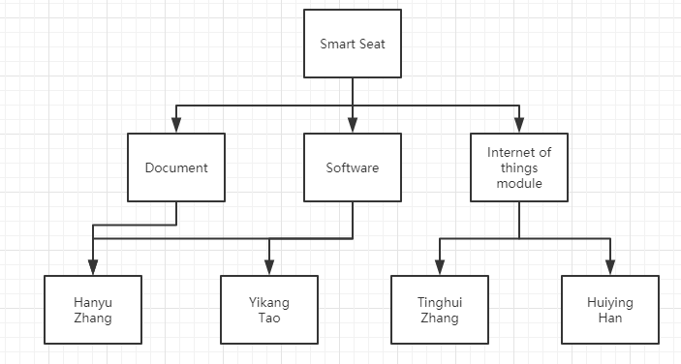

## 3.2 Personnel division of labor

|  |  |  |
| --- | --- | --- |
| Name | Role | Description of work |
| Hanyu Zhang | Project management, preliminary analysis, design, testing | Analyze system requirements, project plan, project team management, check progress, Git branch management and functional module testing and integration |
| Tinghui Zhang | Analysis, the design of the Internet of things module | Analyze the new function, use NodeMcu module and PIR sensor to realize the function of remote monitoring whether the seat is occupied |
| Huiying Han | the design of the Internet of things module | Socket communication is used to receive the seat reservation information of the client, and the indicator light on the seat is remotely controlled by sending instructions to realize the function of seat reservation |
| Yikang Tao | Background management system design, coding | Software framework construction, code module design, database design, project background design and coding |

## 3.3 Collaboration and communication

The waterfall model was adopted for development. Everyone within the team had their own design module, and finally module integration was carried out.

The project team adopts the communication method of meeting every week, 1-2 times, and each time is recorded as a weekly report. The weekly report includes: participants, everyone's project progress, current problems, proposed solutions, plans for the next stage, etc.

# 4 Carry out the plan

## 4.1 Risk assessment and countermeasures

* There is no consensus among developers

All functions should be discussed in meetings before formal development. All problems should be discussed in place. If no agreement is reached, the development should not be carried out until the communication is unified.

* Developers procrastinate

We still need to have a good communication to see where we are not satisfied so we do not cooperate. As for the delayed progress, the corresponding developers should take remedial measures and accept corresponding punishment.

* Tool failure

Replace tools when problems are found.

* The software cannot be completed on schedule

Different engineering stages require different personnel, who can be flexible within the scope of capacity, and work closely with each other to ensure effective software management.

* There is not enough technology available to meet performance requirements

However, the current software developers are not familiar with the current technology, so they should take this issue into consideration and make reasonable tradeoffs when making software development plans and defining milestones.

## 4.2 Overall schedule

# 5 The budget

## 5.1 The cost of equipment

|  |  |  |
| --- | --- | --- |
| Name | Count | Price |
| Nodemcu | 1 | ￥25 |
| PIR | 1 | ￥6 |
| Diode | 1 | ￥20 |

## 5.2 Personnel costs

No developer costs.

## 5.3 Other budget

Project weekly meeting will produce partial defray, specific and according to the circumstance to decide.

Smart Seat

Gannt Chart

**Group members：**Hanyu Zhang, Tinghui Zhang, Huiying Han, Yikang Tao

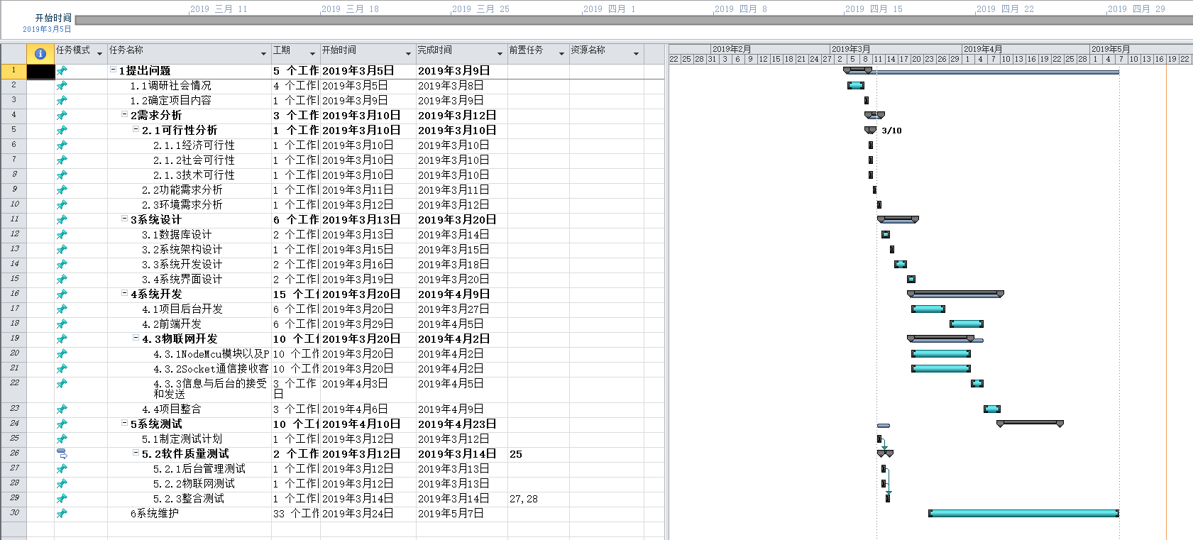

Smart Seat

Statement Of Work V1.0

(SOW)

**Group members：**Hanyu Zhang, Tinghui Zhang, Huiying Han, Yikang Tao

# Document control

## Modify the record

|  |  |  |  |
| --- | --- | --- | --- |
| **Date** | **Author** | **Version** | **Note** |
| 2019-1-18 | Hanyu Zhang | 1.0 |  |
|  |  |  |  |
|  |  |  |  |
|  |  |  |  |

## Review

|  |  |
| --- | --- |
| **Name** | **Date** |
|  |  |
|  |  |
|  |  |
|  |  |

## Distribution

|  |  |  |
| --- | --- | --- |
| **Number** | **Name** | **Place** |
|  |  |  |
|  |  |  |
|  |  |  |
|  |  |  |

Directory

1 Overview 4

2 The project scope 5

2.1 Scope of development 5

2.2 Development module scope 5

2.3 Development function scope 5

2.4 Major deliverables 6

3 The main assumptions 7

3.1 Project management 7

3.2 Code work 7

3.3 Test work 7

3.4 Work scope 7

4 Project suspension and termination 9

4.1 Project suspension 9

4.2 Project termination 9

# 1 Overview

The Statement Of Work (hereinafter referred to as "SOW") was intended to define the terms and conditions for the implementation Of the service.

This statement of work defines the specific implementation scope, task, resource plan, implementation plan, basic assumption and delivery items as agreed in the project. In case of any discrepancy with other agreements or agreements, the SOW shall prevail.The SOW will serve as a guidance document for project execution process control and management.

# 2 The project scope

## 2.1 Scope of development

|  |  |
| --- | --- |
| **Number** | **Scope** |
| 1 | Smart seats based on the Internet of things |
| 2 | Intelligent seat background management system based on Web development |

## 2.2 Development module scope

The scope of development module of this project includes the following modules：

|  |  |  |
| --- | --- | --- |
| **Subsystem** | **Number** | **Module** |
| Background management  System | 1 | The welcome page |
| 2 | The Login&Register page |
| 3 | The personal information page |
| 4 | Library seat display page |
| 5 | The report page |
| 6 | The Statistical information page |
| Internet  Of  Things  system | 7 | Information receiving |
| 8 | Information processing |

## 2.3 Development function scope

|  |  |  |
| --- | --- | --- |
| **Num** | **Module** | **Subsystem** |
| 1 | The welcome page |  |
| 2 | The Login&Register page | Register |
| Login |
| 3 | The personal information page | Display the user login name |
| Display user occupancy information |
| Display user credit information |
| 4 | Library seat display page | Show the available library space |
| Reserve seat |
| Transfer the seat occupying information to the internet of things module |
| 5 | The report page | Fill in the repair information |
| 6 | The Statistical information page | Display the current seating information |
| Show the total number of users |
| 7 | Information receiving | Sensors monitor seat status |
| Transmit seat status to backstage |
| 8 | Information processing | The light indicates the seat status |

## 2.4 Major deliverables

|  |
| --- |
| **Deliverables** |
| Project Plan |
| Statement Of Work（SOW） |
| Detailed design specification |
| Interface specification document |
| User manual |
| Project requirements change documentation |

# 3 The main assumptions

In order to ensure the successful implementation of the project, the SOW was based on the following assumptions. The changes in the following assumptions may affect the implementation plan and service price of the project.

## 3.1 Project management

The members of the project team are able to follow the work plan of the project and work on the project according to the resource plan during the whole project implementation;

Any third party factors that may affect the project plan shall be controlled and managed by the team leader;

Project implementation success depends largely on the user's coordination, able to timely solve the problems arising from the project team members in the implementation of the project, in principle, for these problems, the proposed scheme is put forward, the meeting leader should make a final confirmation within 48 hours, for some of the more difficult to solve the problem, is solved by project team members agreed time schedule.

## 3.2 Code work

According to the requirements of the project work plan, project team members can timely provide the finished coding products and relevant documents required for the implementation of the project and meet the requirements of the progress of the whole project.

## 3.3 Test work

The team leader is responsible for providing the test plan, and the project team members are responsible for preparing the test process and test data as required.

In collaboration with all project team members, members will review all test data to ensure that the tests are conducted accurately.

Project team members will prepare test materials, execute tests and test analysis under the guidance of the team leader, and submit project test reports.

## 3.4 Work scope

This project will strictly follow the work scope of this SOW is to define any increase, enhance or modify the through the change control process as change request processing because of the implementation of the project for the adjustment of the organizational structure, business model, so as to affect the project team has confirmed system design and project implementation plan, responsibility will be Shared by members of the team.

# 4 Project suspension and termination

## 4.1 Project suspension

Project suspension means that the project needs to be suspended for various reasons and the project will be restarted within the expected time in the future.

The project suspension order must be issued by the project leader, and the project work shall be carried out according to the original plan before the project leader group issues the project suspension order.

If the project resumes, the original development team needs to be retained.

Otherwise, party b will not promise that the project team will be the original development team.

The maximum time to organize the team shall not exceed 1 day for the project resumption.

## 4.2 Project termination

The termination of the project must be decided by the project team.

Before the project leader issues the project termination order, the project work shall be carried out as planned.

After the project termination order is issued, the project leader completes the project termination plan.

This termination plan must include the type and amount of termination fee.

If there is any dispute about the project termination plan and the cost, the project team shall agree.

Smart Seat

Details Design V1.0

**Group members：**Hanyu Zhang, Tinghui Zhang, Huiying Han, Yikang Tao

Directory

Smart Seat **错误!未定义书签。**

1 Introduction **错误!未定义书签。**

1.1 Purpose of writing **错误!未定义书签。**

1.2 Background **错误!未定义书签。**

1.3 Terminology and abbreviation **错误!未定义书签。**

1.4 Reference **错误!未定义书签。**

1.5 Standards、conditions and conventions **错误!未定义书签。**

2. Overall design **错误!未定义书签。**

2.1 Project Objectives **错误!未定义书签。**

2.2 Overview of requirements **错误!未定义书签。**

2.3 Software structure **错误!未定义书签。**

2.4 Project development environment **错误!未定义书签。**

2.5 Detailed design methods and tools **错误!未定义书签。**

2.5.1 E-R diagram **错误!未定义书签。**

2.5.2 Program flow chart **错误!未定义书签。**

3 System detailed requirements analysis **错误!未定义书签。**

3.1 Detailed functional requirements analysis **错误!未定义书签。**

3.2 Functional block diagram **错误!未定义书签。**

3.3 Overall system requirements **错误!未定义书签。**

3.4 Use case diagram analysis **错误!未定义书签。**

3.5 Detailed function description **错误!未定义书签。**

3.5.1 Registration & Login module **错误!未定义书签。**

3.5.2 Seat reservation module **错误!未定义书签。**

3.5.3 Seat repair module **错误!未定义书签。**

3.5.4 Seat information inquiry module **错误!未定义书签。**

3.5.5 Personal information inquiry module **错误!未定义书签。**

3.5.6 Administrator mailbox module **错误!未定义书签。**

3.5.7 PIR sensor remote monitoring seat module **错误!未定义书签。**

3.5.8 Socket communication remote access indicator module **错误!未定义书签。**

3.6 Interface design **错误!未定义书签。**

3.6.1 Internal interface **错误!未定义书签。**

3.6.2 External interface **错误!未定义书签。**

3.6.3 User interface **错误!未定义书签。**

4 Database Design **错误!未定义书签。**

4.1 User **错误!未定义书签。**

4.2 Admin **错误!未定义书签。**

4.3 Seat **错误!未定义书签。**

4.4 Reserve **错误!未定义书签。**

4.5 Repair **错误!未定义书签。**

5 System error handling design **错误!未定义书签。**

5.1 System error remedy **错误!未定义书签。**

5.2 System maintenance design **错误!未定义书签。**

6 System test **错误!未定义书签。**

6.1 System test review **错误!未定义书签。**

6.2 Login & Register module test **错误!未定义书签。**

6.3 Reserve module test **错误!未定义书签。**

6.4 Repair module test **错误!未定义书签。**

6.5 PIR sensor module test **错误!未定义书签。**

6.6 Indicate light module test **错误!未定义书签。**

# 1 Introduction

## 1.1 Purpose of writing

The purpose is to:

* Provide evidence for the coders；
* Provide conditions for modification and maintenance；
* The project leader will arrange and control the whole process of development work as required by the plan；
* The project quality assurance personnel will perform phased and summarizing quality verification and confirmation according to this plan.

The tone readers of this manual include：

* project developers, especially coding staff；
* Software maintenance personnel；
* technical management personnel；
* Participate in the verification, confirmation and relevant personnel responsible for the final report acceptance and appraisal of the project.

## 1.2 Background

At present, there are many seats in major university libraries, but there are still a large number of seats in short supply during the peak period of use. Occasionally, individual students may experience unpleasantness due to occupying behavior. Many students will also find a place to study and read a lot of time after a long search in the library, which greatly reduces the enthusiasm of the students.

At present, the library equipment is perfect, but the repair is not timely. It often happens that although there is a location, it is not properly used due to the damage of the hardware facilities.

The project's entrusting unit, development unit and competent department:

Entrusted by: Software Project Management Course, School of Information Engineering, Shanghai Maritime University

Development unit: the eighth group

Competent department: School of Information Engineering, Shanghai Maritime University

## 1.3 Terminology and abbreviation

Terminology:

**PIR:** PIR is the abbreviation of Passive Infrared, which is passive infrared technology. The full name of the PIR detector is the Passive Infrared Detector, which is a passive infrared detector or body sensor. Sometimes called Passive Infrared Sensor, the detector in the security industry is called Detector.

**NodeMcu:** An open source IoT platform. It is programmed using the Lua scripting language. The platform is based on the eLua open source project, which uses the ESP8266 sdk 0.9.5 version. The platform uses many open source projects, such as lua-cjson, spiffs. The NodeMCU contains firmware that runs on the esp8266 Wi-Fi SoC chip, as well as hardware based on ESP-12 modules.

**MySQL:** MySQL is a relational database management system developed by MySQL AB of Sweden and currently owned by Oracle. MySQL is one of the most popular relational database management systems. MySQL is the best RDBMS (Relational Database Management System) application for WEB applications.

**SQL:** A special purpose programming language, a database query and programming language for accessing data and querying, updating, and managing relational database systems; it is also the extension of database script files.

**Transaction flow:** Entering the system along the incoming path, transforming from the external form to the internal form, and then arriving at the transaction center. The transaction center selects one of several action paths according to the data item evaluation result. Have a transaction like this.

Abbreviation:

**SQL:** Structured Query Language.

**UML:** Unified Modeling Language, a set of standard modeling languages for designing software blueprints, is a standardized modeling language from software analysis and design to programming specification.

## 1.4 Reference

《Software project management》Rajeev T Shandilya Science press

《UML and pattern applications》Craig Larman Machinery industry press

National standards document for software engineering

## 1.5 Standards、conditions and conventions

The project follows the following standards:

**GB/T** computer software classification and code

**GB/T** information technology

**GB/T** software engineering

**GB/T** software engineering standard taxonomy

**GB/T** computer test documentation

**GB/T** computer software requirements specification

**GB/T** computer software testing specifications

**GB/T** information technology programming language

**GB/T** information technology software engineering

**GB/T** computer software documentation specifications

# 2. Overall design

## 2.1 Project Objectives

* Designing an intelligent occupancy system sample based on the Internet of Things.
* Develop a smart occupancy background management system that can be put into use.

## 2.2 Overview of requirements

（1）System administrator requirements：

1. Managing seat conditions
2. Check the repair information
3. Manage user information

（2）User requirements：

1. Login
2. Register
3. Seat reservation
4. Repair
5. Search for seat information
6. View personal information

（3）Intelligent device networking：

1. PIR sensor detection information
2. NodeMcu platform uploads received data via WiFi
3. The web receives feedback and clicks on the light

## 2.3 Software structure

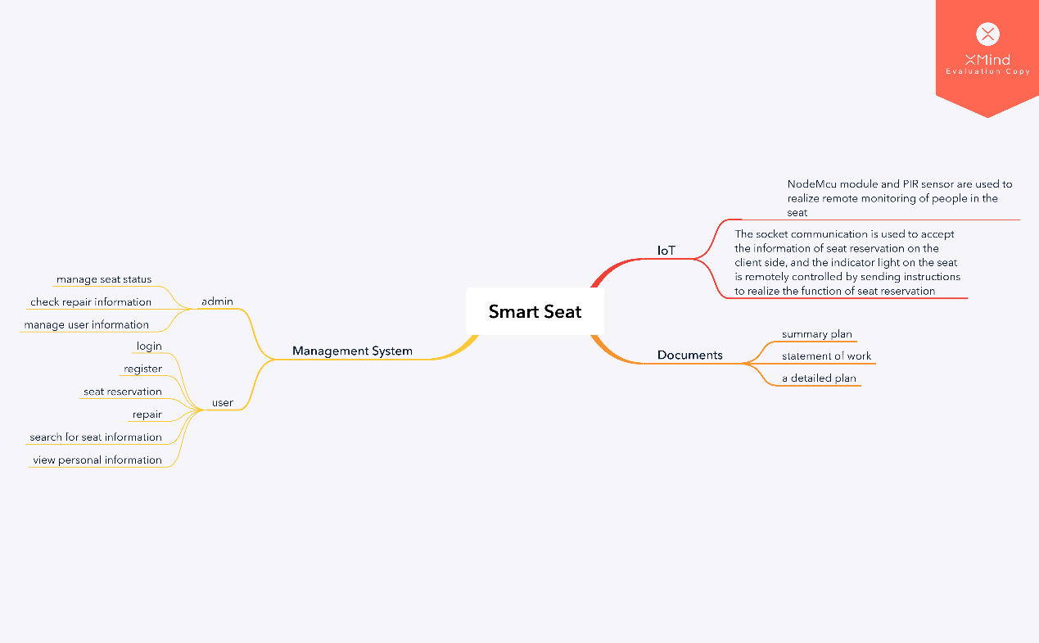Figure2-1 Software detailed structure diagram 1

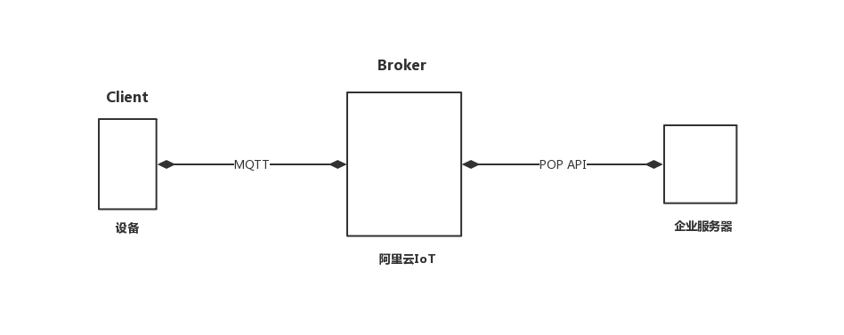

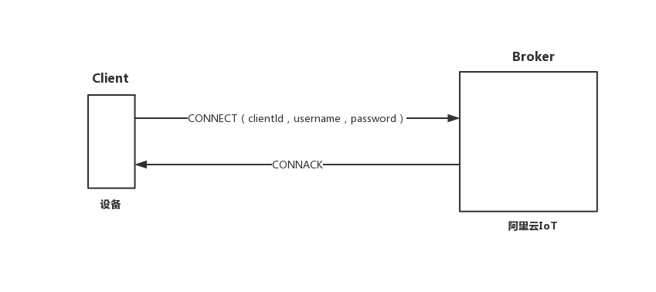Figure2-2 Software detailed structure diagram 2

Figure2-3 Software detailed structure diagram 3

## 2.4 Project development environment

Support conditions needed during development:

Hardware:

* Server: Pentium III above 500 or higher
* RAM：over 128M
* ROM：at least 10G above

Software:

* The operating system is Windows 8 or above, and the integrated development tools Arduino IDE and PyCharm are used. MySQL is used as the database, and the project running environment is apache2.4.

## 2.5 Detailed design methods and tools

### 2.5.1 E-R diagram

The E-R diagram, also known as the Entity Relationship Diagram, provides methods for representing entity types, attributes, and connections to describe real-world conceptual models.

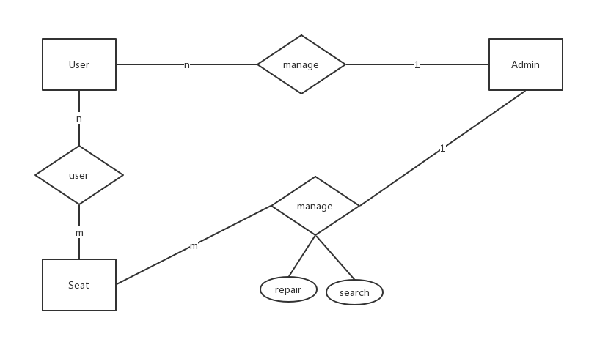It is an effective way to describe the conceptual model of real world relations. Is a way of representing a conceptual relationship model. Use "rectangular box" to represent the entity type, the rectangle box to indicate the entity name; use "ellipse frame" to represent the attribute of the entity, and use "solid line segment" to connect it with the "physical type" of the corresponding relationship;

Figure2-4 E-R diagram

### 2.5.2 Program flow chart

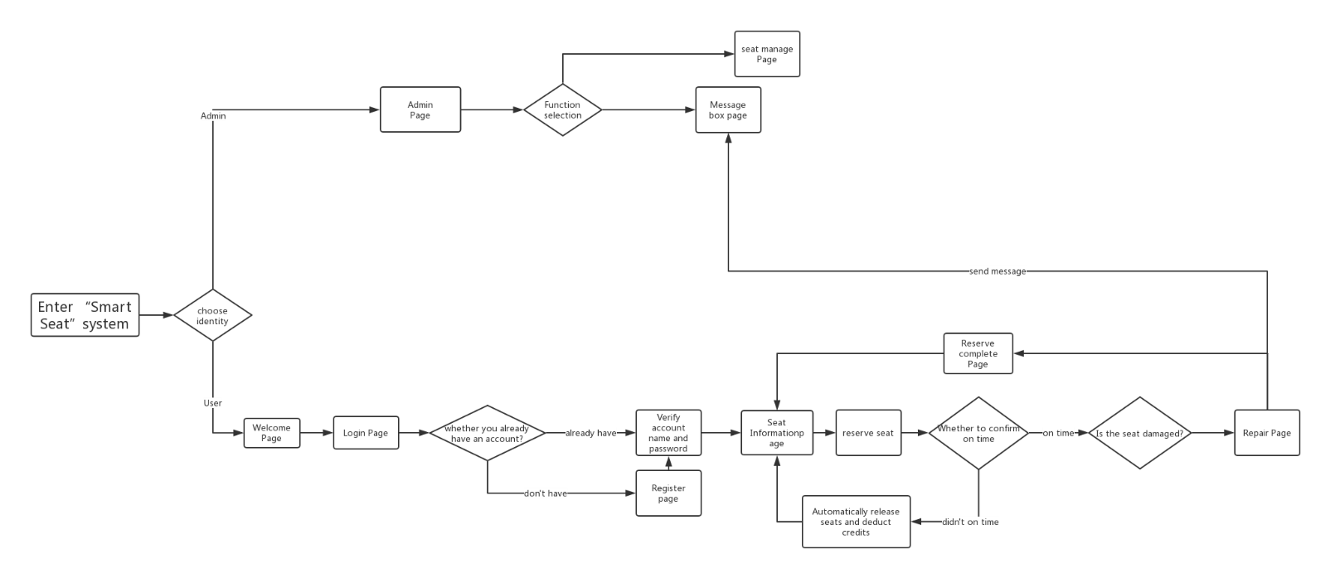The program flow diagram, also called the block diagram, is a graphical representation of the specific steps of the program running with the standard symbols specified. The block diagram is designed based on the processing flow chart, through the detailed analysis of the input and output data and processing, the main operating steps and content of the computer are identified. The block diagram is the most basic basis for programming, so its quality is directly related to the quality of programming.

Figure2-5 Program flow chart

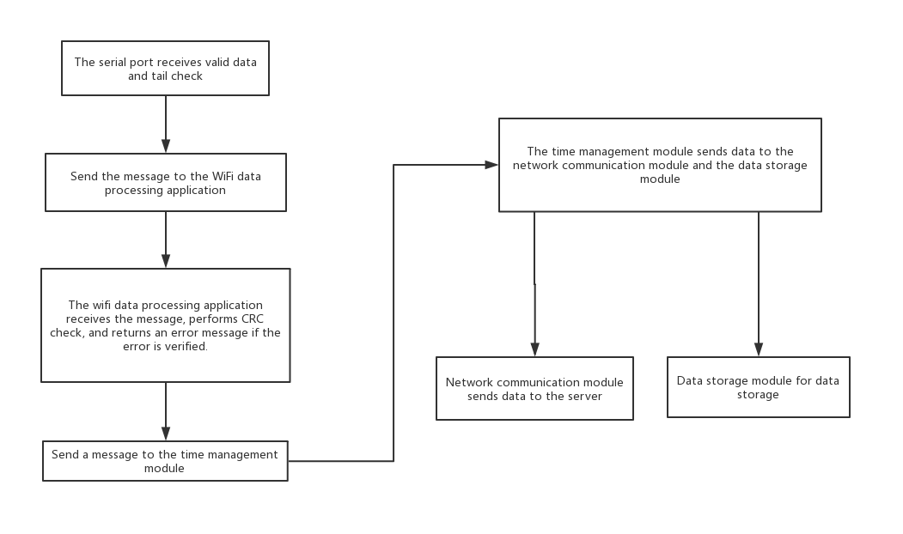

Figure2-6 IoT module flow chart

# 3 System detailed requirements analysis

## 3.1 Detailed functional requirements analysis

This system has the following function modules:

1. Register the login module
2. Seat reservation module
3. Seat repair module
4. Seat information inquiry module
5. Personal Information Query Module
6. Administrator Mailbox Module
7. PIR sensor remote monitoring seat module
8. Socket communication remote access indicator module

## 3.2 Functional block diagram

Figure3-1 Functional block diagram

## 3.3 Overall system requirements

|  |  |  |
| --- | --- | --- |
| The main function | Functional requirements | Quality requirements |
| Login | Enter the account password when logging in to enter the corresponding account. After entering, the system will verify the user's specific identity according to the entered user name and password. If the user name and password are not entered, the user name and password cannot be empty. | Correctness: high  Robustness: high  Performance efficiency: good  Ease of use: good  Security: General  Scalability: good  Compatibility: good |
| Register | When registering, you can select ordinary user registration. When a normal user registers, you need to submit a series of personal information to register successfully. | Correctness: high  Robustness: high  Performance efficiency: good  Ease of use: good  Security: General  Scalability: good  Compatibility: good |
| Seat Reservation | After the user logs in, the seat reservation function can be used normally. After the user successfully reserves the seat, the user must manually confirm the account within the specified time. If the time is not confirmed within the specified time, the seat is automatically released. If the sensor detects that someone is seated within the specified time, If the user does not confirm, a warning will be sent to the administrator mailbox. | Correctness: high  Robustness: high  Performance efficiency: good  Ease of use: good  Security: General  Scalability: good  Compatibility: good |
| Seat Repair | After the user logs in, he can select the seat, click the repair button and fill in the repair information, the system will send the information to the administrator mailbox. | Correctness: high  Robustness: high  Performance efficiency: good  Ease of use: good  Security: General  Scalability: good  Compatibility: good |
| Seat Information Inquiry | After the user logs in, the user can check what status the seat is currently in. | Correctness: high  Robustness: high  Performance efficiency: good  Ease of use: good  Security: General  Scalability: good  Compatibility: good |
| Personal Information Query | After the user logs in, the user can query their related information. | Correctness: high  Robustness: high  Performance efficiency: good  Ease of use: good  Security: General  Scalability: good  Compatibility: good |
| Administrator Mailbox | After the administrator logs in, the administrator can view and receive relevant repair and warning information. | Correctness: high  Robustness: high  Performance efficiency: good  Ease of use: good  Security: General  Scalability: good  Compatibility: good |
| PIR sensor remote monitoring seat module | The PIR sensor can detect the current seat status at all times and send the status information of the current seat to the background. | Correctness: high  Robustness: high  Performance efficiency: good  Ease of use: good  Security: General  Scalability: good  Compatibility: good |
| Socket communication remote access indicator module | If the current seat is reserved, the light is on | Correctness: high  Robustness: high  Performance efficiency: good  Ease of use: good  Security: General  Scalability: good  Compatibility: good |

Table3-1 Quality requirements

## 3.4 Use case diagram analysis

Figure3-1 Use case diagram

|  |  |  |
| --- | --- | --- |
| Number | UC01 | |
| Name | Register | |
| Description | Register as a system user | |
| Primary  participant | User | |
| Precondition | Nothing | |
| Basic event flow | Step | Activities |
| A1 | Click the registration button to register |
| A2 | Fill in a series of personal information |
| A3 | Submit Information |
| Extended event flow | 1a | Basic information input is incorrect |
| 1b | Registration success |

Table3-2 Register use case

|  |  |  |
| --- | --- | --- |
| Number | UC02 | |
| Name | Login | |
| Description | Select user identity to log in to the system | |
| Primary  participant | Administrator、User | |
| Precondition | Already registered as a system user | |
| Basic event flow | Step | Activities |
| A1 | Choose login identity |
| A2 | Enter username and password |
| A3 | Click the confirmation button |
| Extended event flow | 1a | The account or password is empty and the error is displayed. |
| 1b | Account or password does not match, prompt error |

Table3-3 Login use case

|  |  |  |
| --- | --- | --- |
| Number | UC03 | |
| Name | Seat Reservation | |
| Description | Reserve a library seat | |
| Primary  participant | User | |
| Precondition | Already logged in | |
| Basic event flow | Step | Activities |
| A1 | Choose an idle seat to make a reservation |
| A2 | Confirm arrival time within the specified time |
| Extended event flow | 1a | The system automatically releases the seat if it is not confirmed within the specified time. |
| 1b | If the sensor detects that someone is seated within the specified time, If the user does not confirm, a warning will be sent to the administrator mailbox. |

Table3-4 Seat Reservation use case

|  |  |  |
| --- | --- | --- |
| Number | UC04 | |
| Name | Seat Repair | |
| Description | Report library seat damage | |
| Primary  participant | User | |
| Precondition | Already logged in | |
| Basic event flow | Step | Activities |
| A1 | Choose an idle seat to report |
| A2 | Fill in the damage information |
| A3 | Confirm report information |

Table3-5 Seat Repair use case

|  |  |  |
| --- | --- | --- |
| Number | UC05 | |
| Name | Seat Information Inquiry | |
| Description | View current seat status | |
| Primary  participant | User | |
| Precondition | Already logged in | |
| Basic event flow | Step | Activities |
| A1 | Choose a seat |
| A2 | View current seat status |

Table3-6 Seat Information Inquiry use case

|  |  |  |
| --- | --- | --- |
| Number | UC06 | |
| Name | Personal Information Query | |
| Description | View personal information | |
| Primary  participant | User | |
| Precondition | Already logged in | |
| Basic event flow | Step | Activities |
| A1 | Enter the personal center |
| A2 | View personal information |

Table3-7 Personal Information Query use case

|  |  |  |
| --- | --- | --- |
| Number | UC07 | |
| Name | Administrator Mailbox | |
| Description | Check for repairs and warnings | |
| Primary  participant | Administrator | |
| Precondition | Already logged in as administrator | |
| Basic event flow | Step | Activities |
| A1 | Enter the administrator mailbox |
| A2 | View message |

Table3-8 Administrator Mailbox use case

## 3.5 Detailed function description

### 3.5.1 Registration & Login module

It is divided into normal user login and administrator login. The administrator account is unique and does not need to be registered. Ordinary users can only use all the functions of this system only after they have registered an account and logged in.

### 3.5.2 Seat reservation module

It is only restricted to ordinary users. When the credit value of the ordinary user is higher than the critical value, the seat reservation function can be used normally. The seat can be reserved by inquiry. After the user selects the reservation, the user is prompted to successfully reserve the seat. The seat is reached within the specified time and manually confirmed. Successfully booked once. If the predetermined seat is not confirmed manually within the specified time, the system will automatically release the seat and deduct the user credit value.

### 3.5.3 Seat repair module

Only for ordinary user operations, after the ordinary user successfully makes a reservation, the user can choose to enter the repair page, and after inputting relevant repair information, the repair information will be automatically sent to the administrator mailbox, and the administrator will receive the repair information for related processing.

### 3.5.4 Seat information inquiry module

Only for ordinary user operations, ordinary users can view all seat statuses in the current library and make seat reservations by finding free positions.

### 3.5.5 Personal information inquiry module

Both normal users and administrators can operate. Ordinary users can view their current information and current credit values. Administrators can view and modify user related information.

### 3.5.6 Administrator mailbox module

For administrator operations only, the administrator can open the mailbox to view the current seat repair information or suggestions for the system.

### 3.5.7 PIR sensor remote monitoring seat module

Remotely monitor the seat with the NodeMcu module and the PIR sensor. If the seat is currently unoccupied and the seat is not reserved, it will be released as idle.

### 3.5.8 Socket communication remote access indicator module

The socket communication is used to receive the client seat reservation information, and the indicator light on the seat is remotely controlled by sending an instruction. If the user successfully booked the seat but has not confirmed it, the indicator light on the desk lights up, indicating that the person who has not used the system has been occupied.

## 3.6 Interface design

### 3.6.1 Internal interface

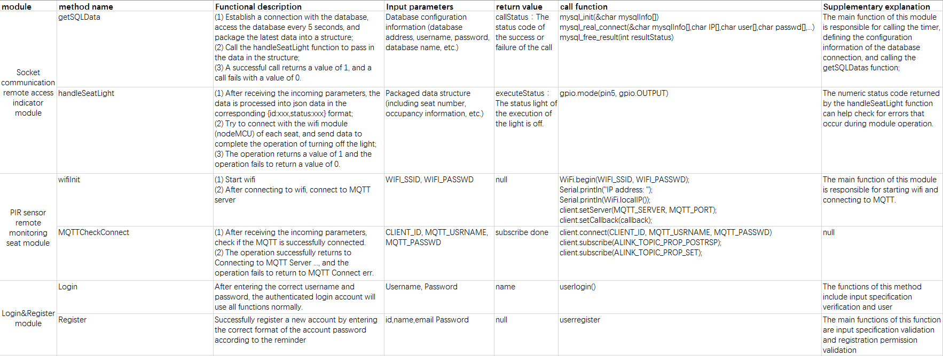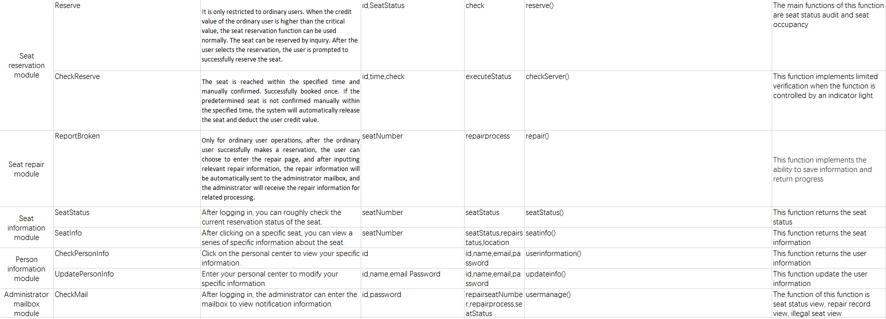

Figure3-2 Internal interface design

### 3.6.2 External interface

Use components and technologies based on the right open standards to ensure maximum collaboration and ease of integration with third-party systems and components. Such standards include but are not limited to the following：

* Network protocols and standards（TCP/IP、HTTP、SSL、etc）
* Language（Python、C、SQL、etc）
* Database connectivity（ADO.net）

### 3.6.3 User interface

Provide users and administrators with an easy-to-use UI and help documentation.

The login page is popped up first, and the user identity is selected for the user to enter a username and password. After the login is successful, you can choose to enter the seat reservation interface. After the reservation is successful, you can select the repair page.

After the administrator logs in successfully, you can choose to enter the seat management page and the administrator mailbox page.

# 4 Database Design

## 4.1 User

|  |  |  |
| --- | --- | --- |
| **User** | | |
| **Name** | **Type** | **Note** |
| UserId | Int | Key |
| Username | Varchar255 |  |
| Password | Varchar255 |  |
| Name | Varchar255 |  |
| Sex | Varchar255 |  |
| Image | Varchar255 |  |
| Birthday | Varchar255 |  |
| Credit value | Int |  |

## 4.2 Admin

|  |  |  |
| --- | --- | --- |
| **Admin** | | |
| **Name** | **Type** | **Note** |
| AdminId | Int | Key |
| Username | Varchar255 |  |
| Password | Varchar255 |  |

## 4.3 Seat

|  |  |  |
| --- | --- | --- |
| **Seat** | | |
| **Name** | **Type** | **Note** |
| SeatId | Int | Key |
| Area | Varchar255 |  |
| Status | Varchar255 | 0-Free，1-Reserving，2-Using |
| Repair | Boolean | 0-intact,1-broken |

## 4.4 Reserve

|  |  |  |
| --- | --- | --- |
| **Reserve** | | |
| **Name** | **Type** | **Note** |
| ReserveId | Int | Key |
| SeatId | Int |  |
| UserId | Int |  |
| Start | Varchar255 |  |
| End | Varchar255 |  |
| Information | Varchar255 |  |

## 4.5 Repair

|  |  |  |
| --- | --- | --- |
| **Repair** | | |
| **Name** | **Type** | **Note** |
| RepairtId | Int | Key |
| SeatId | Int |  |
| UserId | Int |  |
| ReportDate | Varchar255 |  |
| CompleteDate | Varchar255 |  |
| Information | Varchar255 |  |

# 5 System error handling design

## 5.1 System error remedy

Possible workarounds after a failure, including:

a. Backup technology: The backup technology used, when the original system data is lost, the establishment and startup of the enabled copy, such as periodically recording the disk information to the tape is a backup technology for the disk media;

b. Fallback technology: The backup technology used, using another less efficient system or method to obtain some parts of the desired results, such as the automatic system's fallback technology can be manual operation and manual recording of data;

c. Recovery and Restart Technology: The recovery restart technology that will be used to resume software from a point of failure or to re-run the software from the beginning.

## 5.2 System maintenance design

Arrangements made in the internal design of the program for the convenience of system maintenance, including inspection points and dedicated modules specially arranged for inspection and maintenance of the system in the program.

System error handling:

1 Error message:

A. Unable to receive sensor information

B. Login failed, please try again

C. The button is invalid, please try again

2 Remedy information:

A. Hardware restart

B. Software restart

3 system maintenance design:

A. Add or remove existing features based on new user needs

B. System optimization based on user feedback

# 6 System test

## 6.1 System test review

A series of functions of the system have been described in detail above, and this chapter will carry out a crucial test session of the system. In the production process of this project, it is actually the process of repeated testing and running and continuous debugging. We also found many deficiencies in the whole system production process. The following is my specific test plan for each part of the system.

## 6.2 Login & Register module test

|  |  |  |  |  |  |  |
| --- | --- | --- | --- | --- | --- | --- |
| Function test | | | | | | |
| Overview | | | | | | |
| Test number | | | GN001 | | | |
| Functional description | | | User use login and register functions | | | |
| Module manager | | | Yikang Tao | | | |
| tester | | | Huiying Han | | | |
| Use purpose | | | Whether the user can enter the system normally when logging in or registering | | | |
| Precondition | | | User login through the login interface | | | |
| Test operation | | | | | | |
| Number | Input/action | Expected output response | | The actual situation | Correct or not? | Error number |
| 1 | Enter the correct username and password | The system prompts that login/register succeed. | |  |  |  |
| 2 | Enter a username that does not exist, do not fill in the password | The system prompts that login/register failed. | |  |  |  |
| 3 | Enter the correct username and enter the wrong password | The system prompts that login/register failed. | |  |  |  |
| 4 | Enter the wrong username and enter the correct password. | The system prompts that login/register failed. | |  |  |  |
| 5 | Do not fill in the username and password | The system prompts that login/register failed. | |  |  |  |

## 6.3 Reserve module test

|  |  |  |  |  |  |  |
| --- | --- | --- | --- | --- | --- | --- |
| Function test | | | | | | |
| Overview | | | | | | |
| Test number | | | GN002 | | | |
| Functional description | | | User use reserve functions | | | |
| Module manager | | | Yikang Tao | | | |
| tester | | | Huiying Han | | | |
| Use purpose | | | Whether the user can use the reserve function normally | | | |
| Precondition | | | User login through the login interface | | | |
| Test operation | | | | | | |
| Number | Input/action | Expected output response | | The actual situation | Correct or not? | Error number |
| 1 | Click on the free seat to reserve a seat | The system prompts that the reservation is successful. | |  |  |  |
| 2 | Low credit users use the reserve function | The system prompts that the reservation is failed. | |  |  |  |
| 3 | Click on the damaged seat to reserve a seat | The system prompts that the reservation is failed. | |  |  |  |
| 4 | Click on the reserved seat to reserve a seat | The system prompts that the reservation is failed. | |  |  |  |
| 5 | Click on the using seat to reserve a seat | The system prompts that the reservation is failed. | |  |  |  |

## 6.4 Repair module test

|  |  |  |  |  |  |  |
| --- | --- | --- | --- | --- | --- | --- |
| Function test | | | | | | |
| Overview | | | | | | |
| Test number | | | GN003 | | | |
| Functional description | | | User use repair functions | | | |
| Module manager | | | Yikang Tao | | | |
| tester | | | Hanyu Zhang | | | |
| Use purpose | | | Whether the user can use the repair function normally | | | |
| Precondition | | | User login through the login interface | | | |
| Test operation | | | | | | |
| Number | Input/action | Expected output response | | The actual situation | Correct or not? | Error number |
| 1 | The user fills in the repair information normally. | The system prompts that the report is successful. | |  |  |  |
| 2 | User does not fill in the repair information | The system prompts “Please fill in the report information.” | |  |  |  |

## 6.5 PIR sensor module test

|  |  |  |  |  |  |  |
| --- | --- | --- | --- | --- | --- | --- |
| Function test | | | | | | |
| Overview | | | | | | |
| Test number | | | GN004 | | | |
| Functional description | | | The PIR sensor senses if there is someone in the seat and sends the data to the background. | | | |
| Module manager | | | TingHui Zhang | | | |
| tester | | | Huiying Han | | | |
| Use purpose | | | Whether the PIR sensor can be sensed normally and whether the data can be sent normally. | | | |
| Precondition | | |  | | | |
| Test operation | | | | | | |
| Number | Input/action | Expected output response | | The actual situation | Correct or not? | Error number |
| 1 | When someone is in the sensing range. | Prompt someone is here successful and the data is successfully sent to the background. | |  |  |  |
| 2 | No one appears in the sensing area for a long time | Always prompt nobody is here successful and the data is successfully sent to the background. | |  |  |  |

## 6.6 Indicate light module test

|  |  |  |  |  |  |  |
| --- | --- | --- | --- | --- | --- | --- |
| Function test | | | | | | |
| Overview | | | | | | |
| Test number | | | GN005 | | | |
| Functional description | | | The indicator light will light according to the seat status | | | |
| Module manager | | | Huiying Han | | | |
| tester | | | Hanyu Zhang | | | |
| Use purpose | | | Whether the indicator light will light according to the seat status | | | |
| Precondition | | |  | | | |
| Test operation | | | | | | |
| Number | Input/action | Expected output response | | The actual situation | Correct or not? | Error number |
| 1 | Reserve a seat. | The indicator light is on normally. | |  |  |  |
| 2 | Confirm reserve succeed | The indicator light goes out | |  |  |  |
| 3 | Unconfirmed for a long time after reserve. | The indicator light goes out | |  |  |  |

Smart Seat

Test Plan V1.0

**Group members：**Hanyu Zhang, Tinghui Zhang, Huiying Han, Yikang Tao

Directory

Smart Seat 53

1 Introduction 55

1.1 Purpose of writing 55

1.2 Background 55

1.3 Scope 55

1.4 Reference 55

1.5 Test Environment 55

2. Module test 57

2.1 Software description 57

2.2 Test content 57

2.3 Login & Register module test 58

2.4 Reserve module test 60

2.5 Repair module test 60

2.6 PIR sensor module test 61

2.7 Indicate light module test 62

3 Integration Testing 64

3.1 Purpose 64

4 Risks and measures taken during the testing phase 68

5 Evaluation criteria 69

5.1 System structure 69

5.2 Functional aspect 69

5.3 Safety 69

5.4 Reliability 69

5.5 Compatibility 69

# 1 Introduction

## 1.1 Purpose of writing

Test each function module in Smart Seat to meet the user requirements and test whether there is a bug. Expected to achieve rapid system improvement and system improvement. In order to find software errors as much as possible before the software is put into production.

## 1.2 Background

The smart seat system is divided into eight different modules. In this article, the main test is to separately test the eight different modules, and then combine the modules and integrate them to test the corresponding test plan. Different modules must meet different performance standards during the test.

## 1.3 Scope

Whether the functions of the main test software meet the needs of the customer, whether the performance is superior and the problems of the system. Perform detailed tests on each module of the system, record the results of the test, and analyze the results of the test in detail. During the test, each functional module of the system is split and tested, and each module is tested. Test all possible outcomes, as well as analyze problems that exist during the test, and then submit a record of the tests. Finally, a comprehensive analysis of the software problems and performance tests is given and recorded.

In the process of testing, it is necessary to make assumptions about each problem, and to improve the system according to the project function modules and user requirements existing in the requirements report document. List all risks or unexpected events that may affect the design, development, or implementation of the test. List all constraints that may affect test design, development, or implementation.

## 1.4 Reference

《Software project management》Rajeev T Shandilya Science press

《UML and pattern applications》Craig Larman Machinery industry press

National standards document for software engineering

## 1.5 Test Environment

|  |
| --- |
| Environment (related software, hardware, operating system, etc.) |
| Windows10, Operating system, Browser |
| Server deployment is as follows:   1. Operating system: Windows10 Professional 2. Processor: Intel® Core™ i7-7700 CPU @ 3.60GHz 3. Memory Capacity: 8.00G 4. Hard drive capacity: 512G 5. Browser: Google Chrome |
| System internal type: 64-bit operating system, x64-based processor |

# 2. Module test

## 2.1 Software description

## 2.2 Test content

1.Login&Register module test

2.Seat Reservation module test

3.Seat Repair module test

4.Seat Information Inquiry module test

5.Personal Information Query module test

6.Administrator Mailbox module test

7.PIR sensor remote monitoring seat module test

8.Socket communication remote access indicator module test

## 2.3 Login & Register module test

|  |  |  |  |  |  |  |
| --- | --- | --- | --- | --- | --- | --- |
| Function test | | | | | | |
| Overview | | | | | | |
| Test number | | | GN001 | | | |
| Functional description | | | User use login and register functions | | | |
| Module manager | | | Yikang Tao | | | |
| tester | | | Huiying Han | | | |
| Use purpose | | | Whether the user can enter the system normally when logging in or registering | | | |
| Precondition | | | User login through the login interface | | | |
| Test operation | | | | | | |
| Number | Input/action | Expected output response | | The actual situation | Correct or not? | Error number |
| 1 | Enter the correct username and password | The system prompts that login/register succeed. | |  |  |  |
| 2 | Enter a username that does not exist, do not fill in the password | The system prompts that login/register failed. | |  |  |  |
| 3 | Enter the correct username and enter the wrong password | The system prompts that login/register failed. | |  |  |  |
| 4 | Enter the wrong username and enter the correct password. | The system prompts that login/register failed. | |  |  |  |
| 5 | Do not fill in the username and password | The system prompts that login/register failed. | |  |  |  |

## 2.4 Reserve module test

|  |  |  |  |  |  |  |
| --- | --- | --- | --- | --- | --- | --- |
| Function test | | | | | | |
| Overview | | | | | | |
| Test number | | | GN002 | | | |
| Functional description | | | User use reserve functions | | | |
| Module manager | | | Yikang Tao | | | |
| tester | | | Huiying Han | | | |
| Use purpose | | | Whether the user can use the reserve function normally | | | |
| Precondition | | | User login through the login interface | | | |
| Test operation | | | | | | |
| Number | Input/action | Expected output response | | The actual situation | Correct or not? | Error number |
| 1 | Click on the free seat to reserve a seat | The system prompts that the reservation is successful. | |  |  |  |
| 2 | Low credit users use the reserve function | The system prompts that the reservation is failed. | |  |  |  |
| 3 | Click on the damaged seat to reserve a seat | The system prompts that the reservation is failed. | |  |  |  |
| 4 | Click on the reserved seat to reserve a seat | The system prompts that the reservation is failed. | |  |  |  |
| 5 | Click on the using seat to reserve a seat | The system prompts that the reservation is failed. | |  |  |  |

## 2.5 Repair module test

|  |  |  |  |  |  |  |
| --- | --- | --- | --- | --- | --- | --- |
| Function test | | | | | | |
| Overview | | | | | | |
| Test number | | | GN003 | | | |
| Functional description | | | User use repair functions | | | |
| Module manager | | | Yikang Tao | | | |
| tester | | | Hanyu Zhang | | | |
| Use purpose | | | Whether the user can use the repair function normally | | | |
| Precondition | | | User login through the login interface | | | |
| Test operation | | | | | | |
| Number | Input/action | Expected output response | | The actual situation | Correct or not? | Error number |
| 1 | The user fills in the repair information normally. | The system prompts that the report is successful. | |  |  |  |
| 2 | User does not fill in the repair information | The system prompts “Please fill in the report information.” | |  |  |  |

## 2.6 PIR sensor module test

|  |  |  |  |  |  |  |
| --- | --- | --- | --- | --- | --- | --- |
| Function test | | | | | | |
| Overview | | | | | | |
| Test number | | | GN004 | | | |
| Functional description | | | The PIR sensor senses if there is someone in the seat and sends the data to the background. | | | |
| Module manager | | | TingHui Zhang | | | |
| tester | | | Huiying Han | | | |
| Use purpose | | | Whether the PIR sensor can be sensed normally and whether the data can be sent normally. | | | |
| Precondition | | |  | | | |
| Test operation | | | | | | |
| Number | Input/action | Expected output response | | The actual situation | Correct or not? | Error number |
| 1 | When someone is in the sensing range. | Prompt someone is here successful and the data is successfully sent to the background. | |  |  |  |
| 2 | No one appears in the sensing area for a long time | Always prompt nobody is here successful and the data is successfully sent to the background. | |  |  |  |

## 2.7 Indicate light module test

|  |  |  |  |  |  |  |
| --- | --- | --- | --- | --- | --- | --- |
| Function test | | | | | | |
| Overview | | | | | | |
| Test number | | | GN005 | | | |
| Functional description | | | The indicator light will light according to the seat status | | | |
| Module manager | | | Huiying Han | | | |
| tester | | | Hanyu Zhang | | | |
| Use purpose | | | Whether the indicator light will light according to the seat status | | | |
| Precondition | | |  | | | |
| Test operation | | | | | | |
| Number | Input/action | Expected output response | | The actual situation | Correct or not? | Error number |
| 1 | Reserve a seat. | The indicator light is on normally. | |  |  |  |
| 2 | Confirm reserve succeed | The indicator light goes out | |  |  |  |
| 3 | Unconfirmed for a long time after reserve. | The indicator light goes out | |  |  |  |

# 3 Integration Testing

## 3.1 Purpose

The main purpose is to determine whether the system meets the requirements for the processing of business processes and data flows to meet the standards. The detection system has logic rigor and errors in the processing of business flows, and whether there are unreasonable standards and requirements for detecting requirements. This phase tests tests based on functional completion

## 3.2 Login & Register

|  |  |
| --- | --- |
| Test target | Detect the functionality and uniformity of the login and registration system |
| Test scope | Login function, registration function, registered user can log in successfully |
| Technology | According to the results obtained by different test cases, infer the completeness of the system function, robustness |
| Starting standard | The test case is complete and the system is running normally. |
| Completion criteria | 1 After the login is successful, the interface jumps to the user's main interface.  2 After successful registration, jump to the recommended login interface.  3 Unregistered user login display is not registered  4 substandard input shows the corresponding error message |
| Test focus and priority | The test focuses on whether the registered user can log in successfully, and whether the registered user can register repeatedly.  First test login, then register |
| Special matters to consider | Should take into account the test error caused by incorrect input |

## 3.3 Reserve & Repair seat

|  |  |
| --- | --- |
| Test target | Timeliness and accuracy of inspection repair function |
| Test scope | Whether the user's application for repair can be viewed by the administrator, and the repair information submitted by the user is accurate. |
| Technology | Submit the repair information through user login with different permissions, and view these repair information through the administrator interface. |
| Starting standard | The system is running normally, and the login registration function is perfect. |
| Completion criteria | 1 different users submit repair information in the same location, no error message will appear  2 The repair information submitted by users with different permissions can be viewed by the administrator.  3 After the administrator finishes the repair information, it will return the processed signal to the corresponding user. |
| Test focus and priority | The key point is whether the repair information submitted by the user can be viewed by the administrator accurately.  The first is to test the submission of repair information, and then the accuracy of the test information. |
| Special matters to consider | The repair information should be sorted in chronological order and repair level. It is necessary to consider that the low-level repair information has been delayed and not processed. |

## 3.4 Tip light

|  |  |
| --- | --- |
| Test target | 1. Test whether the database data acquisition is normal;  2. The correctness of the format after the test data is parsed;  3. Test the correctness of the data stream transmitted to each node (small light). |
| Test scope | Starting from the acquisition of the database data by the coordinator, the operation of turning on or off the small lamp is normally completed. |
| Technology | Use valid and invalid data to perform data acquisition and transmission, verify the following:  1. If the database data is invalid (the structure is empty), the function execution is interrupted, and the status code is 0. If there is data, the status code is returned to 1.  2. If the data is successfully transmitted to the small light node and responds successfully, the function returns the status code 1, otherwise the function is interrupted and returns 0;  3. Test the sample data multiple times to see if it can achieve the desired goal. |
| Starting standard | 1. The data structure of the data acquisition package cannot be empty;  2. The parsed data format must be in json format;  3. The small light node must have a response when transmitting the opposite instruction. |
| Completion criteria | All functional requirements are implemented when the module is running, and all defects found have been resolved. |
| Test focus and priority | Test focus: The data needs sufficient stability in the process of coordinator transmission to the small light node, multiple transmission tests, the success rate of the transmission, and consider adding the ack mechanism to avoid message loss.  priority:  1. Data transmission;  2. Acquisition of database data;  3. Analysis of the data. |
| Special matters to consider | 1. Because it is wireless data transmission, it is susceptible to external interference, so there may be a delayed response;  2. When the data of the database is obtained, since the module is de-duplicated by the timestamp, when the seat occupancy is performed by multiple people at the same time, the information acquisition may be lost. It may be considered to use the snowflake algorithm to alternately generate the random id to avoid the above problem. |

## 3.5 PIR sersor

|  |  |
| --- | --- |
| Test target | Check if the PIR sensor can detect people |
| Test scope | Within a few meters of the desk with PIR sensor |
| Technology | Infrared technology-based automatic control products, when someone enters the switch sensing range, the special sensor detects the infrared spectrum change of the human body, the switch automatically turns on the load, the person does not leave and is active, the switch continues to conduct, and the person leaves, the switch delays Automatically turn off the load |
| Starting standard | The human body activity is detected within the detection range, the induction light is on, and the sensor light is off after the person leaves. |
| Completion criteria | The test light is on as scheduled and the monitor successfully displays the presence or absence of human activity |
| Test focus and priority | The focus of the test is whether the monitor can successfully display the results |
| Special matters to consider | Due to financial and technical constraints, the PIR sensor can only detect one human activity signal at a time. |

# 4 Risks and measures taken during the testing phase

* Personnel cannot be in place in time

Measures taken: 1. Report staff requirements in advance, 2. Subdivision work

* Insufficient staff skills need to be strengthened

Measures taken: 1. Strengthen training and practice; 2. Modify plans appropriately to reduce task intensity

Delay in development submission date, insufficient test time

Measures taken: 1. Complete the preparatory work as early as possible; 2. Examine the test plan and make certain adjustments if allowed.

* Insufficient estimate

Measures taken: 1. Adjust resource input; 2. Correct the plan in time and report the amendment

# 5 Evaluation criteria

## 5.1 System structure

The system architecture is advanced and simple. The system adopts advanced B/S architecture, back-end supports various size databases, and the system structure is clear and clear, which can meet the requirements of network software applications.

## 5.2 Functional aspect

The software consists of Seat reservation, repair modules, etc. covering all the business functions of the smart seat system, so as to ensure the normal use of a series of functions such as scheduling and repair, and the normal transmission of data.

## 5.3 Safety

The system must have strict permission setting function. Different rights personnel can only see the content that they have permission to access, effectively guarantee data security, and encrypt data with encryption technology to improve data security.

## 5.4 Reliability

For the user to input data that does not meet the requirements, a brief and accurate prompt message is given, and assistance is provided if necessary.

## 5.5 Compatibility

Can meet the normal use of software in various operating systems.

Smart Seat

Risk Plan V1.0

**Group members：**Hanyu Zhang, Tinghui Zhang, Huiying Han, Yikang Tao

# 1 Risks

## Personnel Risk

* Team member time and other things conflict.
* Team members can’t participate for a long time.
* The project manager is unreasonable in assigning team members, which makes the subsequent work impossible.

## Technical Risk

* Technical failure.
* Difficulties in technical problems cannot be solved, lack of systematic technical training.
* Lack of support between new technologies and existing technologies.

## 1.3 Demand Risk

* The needs within the group are constantly changing and constantly improving
* The cost is not enough, the equipment can not be purchased, the project can not advance the process.
* Due to lack of research, demand cannot meet users and market.

## 1.4 Compatibility Risk

* Because the project is an IoT project, after the module is developed alone, the module may be incompatible when it is summarized.

## 1.5 Management Risk

* The project manager has a poor plan when planning.
* The project manager does not have a good understanding of the capabilities of the group during the division of labor.
* Lack of good communication between people in the project team.

# 2. Countermeasures

## 2.1 Personnel Risk

* When developing a project plan, the time interval should be appropriately widened when assigning task time, taking into account the risk of time conflicts.
* Reassign project plans by assigning member tasks that cannot participate in the project to other members on average.
* Project managers should familiarize themselves with each member's areas of expertise and competency prior to developing a project plan to further develop project plans and schedules so that projects can be completed more efficiently.

## 2.2 Technical Risk

* If the technical failure cannot be solved, you should replace the new technology or use other feasible tools as soon as possible. If necessary, you can give up the performance requirements and complete the basic functions first.
* Seeking network or teacher help, you should also consider the learning time when planning your project.
* Find compatibility support, if you can't be compatible, you can give up the use of new technology

## 2.3 Demand Risk

* Modify the project plan in time according to different needs.
* On the basis of meeting the project plan, seek low-cost equipment, if it is unable to meet the current requirements, adjust project requirements or think about other solutions in a timely manner.
* Before doing the project plan, do a good job in market research and use iteration when you complete the project. You can find test users to participate in the development work.

## 2.4 Compatibility Risk

* Plan B when doing the project plan, consider using other tools to implement or other solutions to meet current needs.

## 2.3 Management Risk

* After the project manager finishes the project plan, he can modify the project plan according to the suggestions of the team members.
* Project managers should familiarize themselves with each member's areas of expertise and competency prior to developing a project plan to further develop project plans and schedules so that projects can be completed more efficiently.
* Properly arrange project group meetings, or group activities, to promote communication between members.

Smart Seat

The First Presentation

**Group members：**Hanyu Zhang, Tinghui Zhang, Huiying Han, Yikang Tao

Smart Seat

The Second Presentation

**Group members：**Hanyu Zhang, Tinghui Zhang, Huiying Han, Yikang Tao

Smart Seat

Test Cases

**Group members：**Hanyu Zhang, Tinghui Zhang, Huiying Han, Yikang Tao

# 1 Result

## Test tools and performance

|  |  |  |
| --- | --- | --- |
| **Tool name** | **Tool use** | **Tool version** |
| Jmeter | Used to test monitoring platform performance | V2.13 |
| FireBug | Used to troubleshoot web performance | V2.0.8 |

This monitoring platform test uses the open source performance testing tool Jmeter to simulate the user to send a request to access the platform, control the number of virtual users through the Jmeter thread group control, and load test the system under test. If you find that some pages have a slow load time for a single visit during the test web application, use the FireBug tool to troubleshoot.

## Test procedure and function definitions

|  |  |  |
| --- | --- | --- |
| **Program name** | **Program main implementation function** | **Instructions for use** |
| Feinno_onenet_emulator | Analog DTU device like device cloud upload monitoring data | Send 46,000 messages to the terminal program every 5 minutes after startup |

## Platform overall load test

|  |  |  |  |  |  |
| --- | --- | --- | --- | --- | --- |
| **Monitoring platform overall load test** | | | | | |
| Testing purposes | The maximum access peak that the test platform can withstand | | | | |
| Number of concurrent users | Average response time | Throughput | Error rate | System resource occupation | Test Results |
| 100 | 960ms | 50 | 0 | Cpu:10% RAM:30% | Pass |
| 200 | 2157ms | 62 | 0 | Cpu:35% RAM:30% | Pass |
| 500 | 6828ms | 59 | 0 | Cpu:20% RAM:35% | Pass |
| 600 | 8569ms | 59 | 0 | Cpu:20% RAM:35% | Pass |
| 700 | 8662ms | 52 | 0.37% | Cpu:20% RAM:35% | Failure |
| 800 | 9715ms | 68 | 3.7% | Cpu:10% RAM:40% | Failure |
| Test conclusion | (1) In a stand-alone environment, the platform can support up to 600 concurrent users.  (2) The maximum throughput of the platform is 62 requests per second. | | | | |

## 1.4 Platform overall stability test

|  |  |  |  |  |  |
| --- | --- | --- | --- | --- | --- |
| **Monitoring platform overall stability test** | | | | | |
| Testing purposes | Test platform can run stably with maximum access peak | | | | |
| Number of concurrent users | Average response time | Throughput | Error rate | System resource occupation | Test Results |
| 600-1h | 7716ms | 56 | 0 | Cpu:10% RAM:30% | Pass |
| 600-2h | 14302ms | 35 | 0 | Cpu:10% RAM:30% | Pass |
| Test conclusion | The platform can continue to run for at least 2 hours with continuous access by 600 concurrent users. | | | | |

## 1.5 Data uploading test

|  |  |  |  |  |  |
| --- | --- | --- | --- | --- | --- |
| **Data uploading test** | | | | | |
| Testing purposes | The test program handles the speed at which data is sent. | | | | |
| Upload/send | Processing total message | Total time | Error rate | System resource occupation | Test Results |
| Upload | 29459 | 5s | 0 | Cpu:10% RAM:30% | Pass |
| 46363 | 8s | 0 | Cpu:10% RAM:30% | Pass |
| 171626 | 58s | 0 | Cpu:10% RAM:30% | Pass |
| Send | 35101 | 80s | 0 | Cpu:10% RAM:30% | Pass |
| 310000 | 9min | 0 | Cpu:10% RAM:30% | Pass |
| Test conclusion | The ability of the Terminal program to receive upload data is: 5892 pieces/s  The ability of the Terminal program to process the data is: 439/s | | | | |

# 2. Partial Result Screenshot

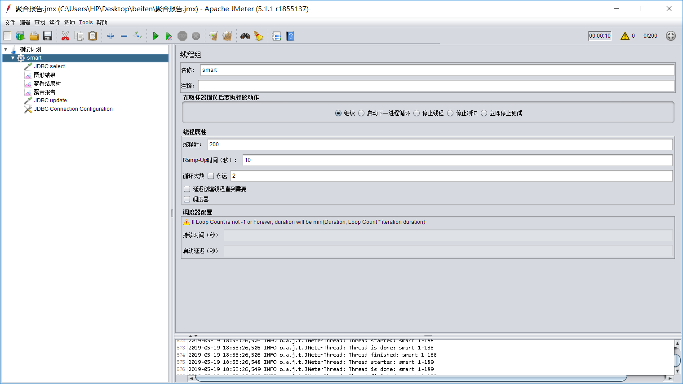

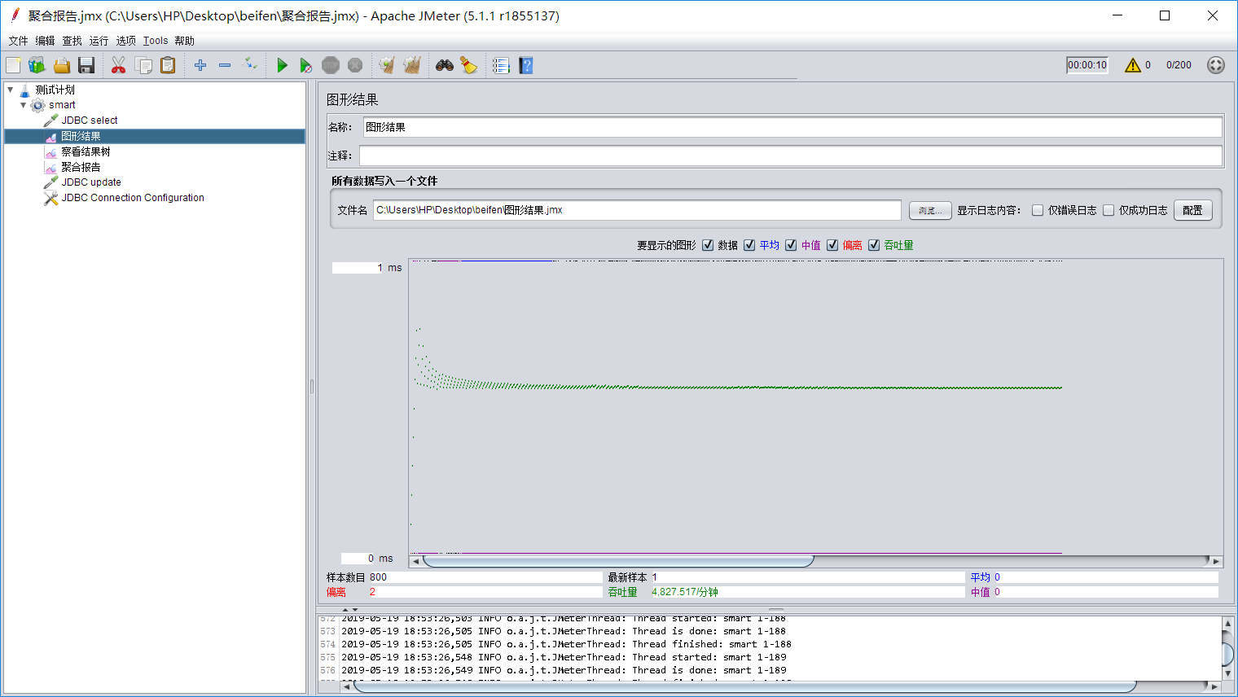

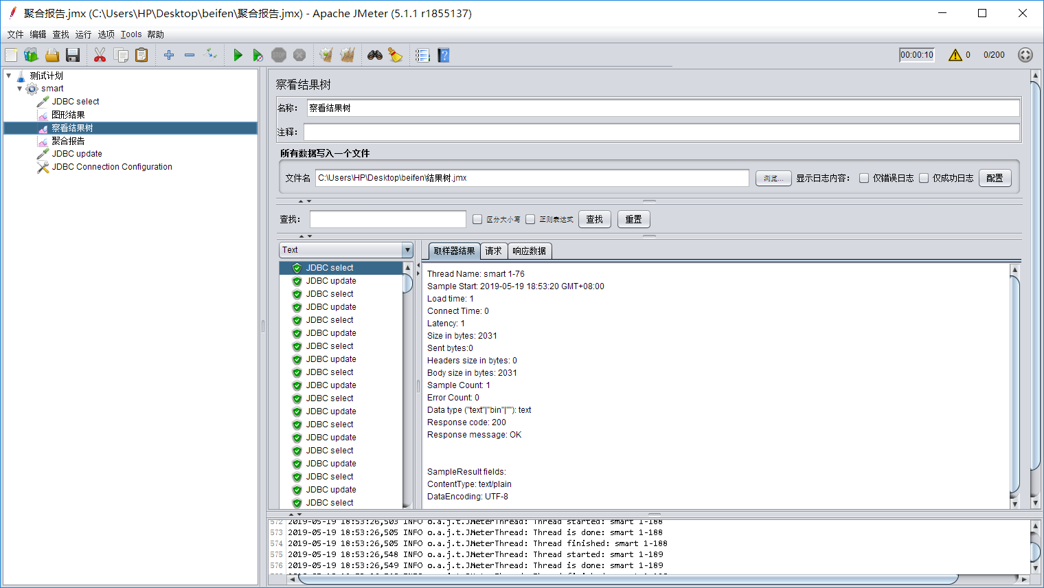

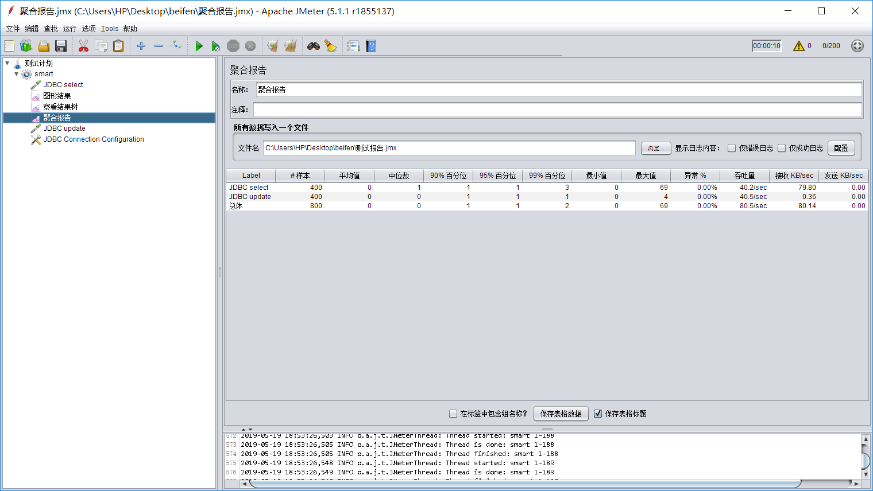

Smart Seat

Lessons Learnt

**Group members：**Hanyu Zhang, Tinghui Zhang, Huiying Han, Yikang Tao

First of all, at the beginning of the project, each member can put forward his own ideas on the requirements, thus perfecting his own final project. After the demand has a certain prototype, the project manager estimates the difficulty of the project in advance according to the responsibility of the project, and according to the team's ability The demand will be further reduced.

As a project manager, the overall project plan should be developed before the project starts. In order to develop a good project plan, first of all, we must understand the scope and scope of each member of the team. Secondly, we must **understand the ability of the project team members**, according to the team members. The size of their ability to work to assign tasks to schedule time.

In the development of the project plan, the overall task must be divided into many small module tasks, and further division, each small module is developed a specific implementation time, and then assigned to members of the project team.

Second, we must **fully consider the risks in the project** before formulating the project plan, and develop different countermeasures according to each risk.

It is best to use an **iterative development model** throughout the project, and to test through the entire development process, allowing users to participate in each iteration to meet the changing needs.

Because our group is an IoT project, there is an IoT module. During hardware development, we must pay attention to the hardware cost risk. During hardware development, we need to pay attention to the **hardware cost**. For higher cost hardware, if there is an alternative option, we can take Replace the part, if not, you can change the requirements as appropriate.

As a project team member, you must first understand your specific tasks, and report your work progress to the project manager in a timely manner, and upload your own code. Also pay attention to your own code format and comments for your code. Members of different divisions of labor and between different links should communicate in a timely manner, that is, for the overall project to be completed efficiently, and for the final integration work to proceed normally.

For testing work, it is necessary to carry out **regression testing** in case the errors that occur in the middle of the change cannot be discovered by the developer in time.

Smart Seat

Future Plan For Next Cycle

**Group members：**Hanyu Zhang, Tinghui Zhang, Huiying Han, Yikang Tao

In the next cycle, we will continue to improve this project, the specific measures are as follows:

Internet of Things module:

1. We will use more sensitive and accurate sensors, but the input cost may increase, which may increase the cost risk in the follow-up, so further analysis of economic feasibility is needed for this item.

2. On the basis of the existing equipment, reduce the cost of hardware other than the sensor, thereby saving, and increasing the feasibility of selecting a more accurate sensor in the first item.

3. Consider placing the sensor at the position of the table, and placing the sensor in a more concealed place will not affect the normal use of the desktop.

Web module

1. Improve the aesthetics of the UI.

2. Further comprehensively test the system to enhance the stability of the system. On the existing basis, increase the throughput of the system, and ensure that when a large number of users use the system, it will not cause the system to be stuck.

3. Add more functions: prompt the seat time, join the credit system, etc.

4. Enhance the interactivity of the system.

5. Introduce the recommendation system to the system.